PT YOGMA WIJAYA KUSUMA -TELL PROJECT

1. 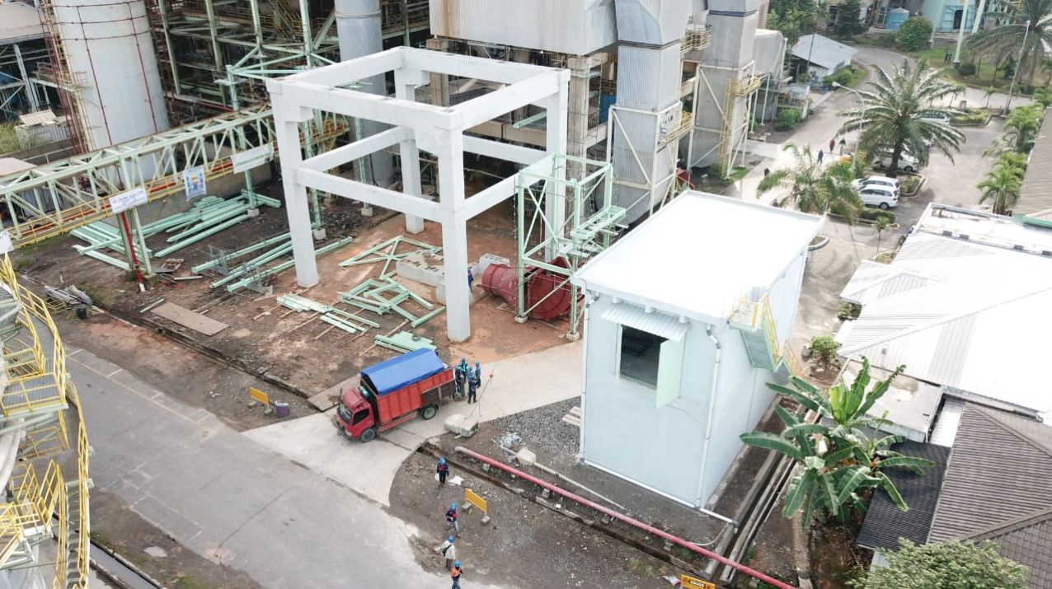CONSTRUCT ESP #3 FOUNDATION & ELECTRICAL ROOM

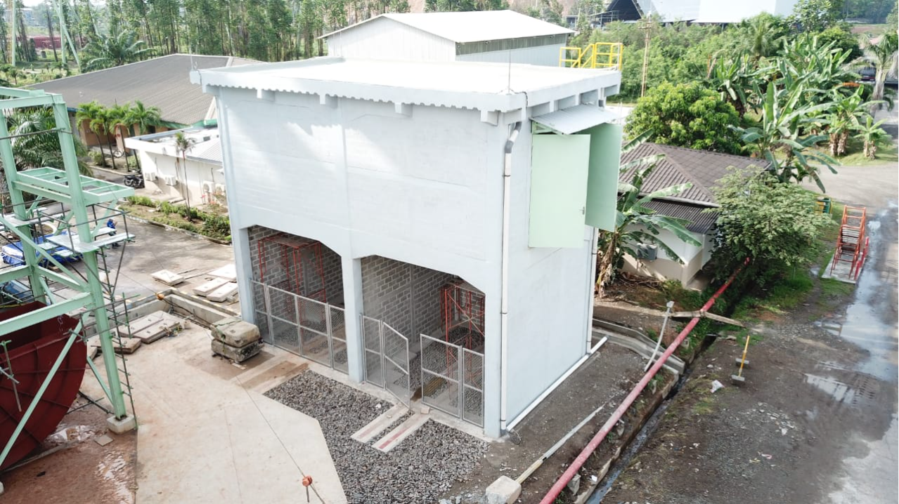

1. 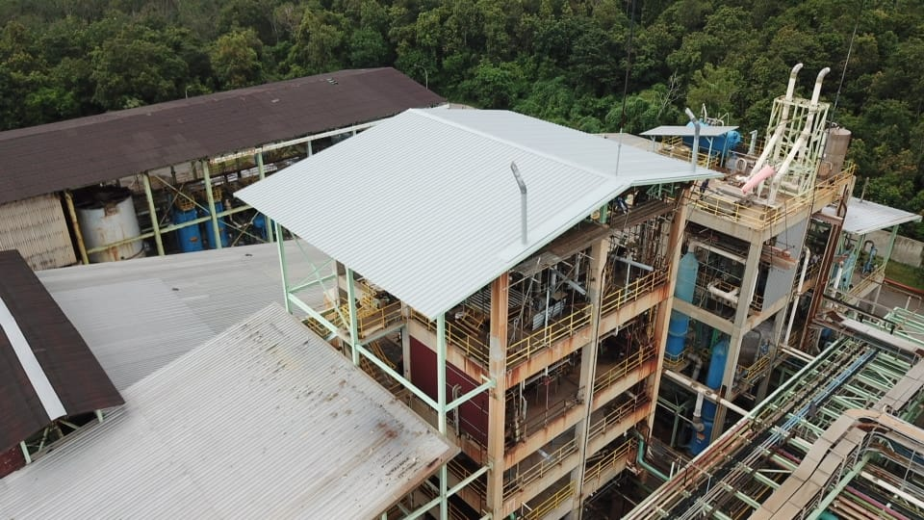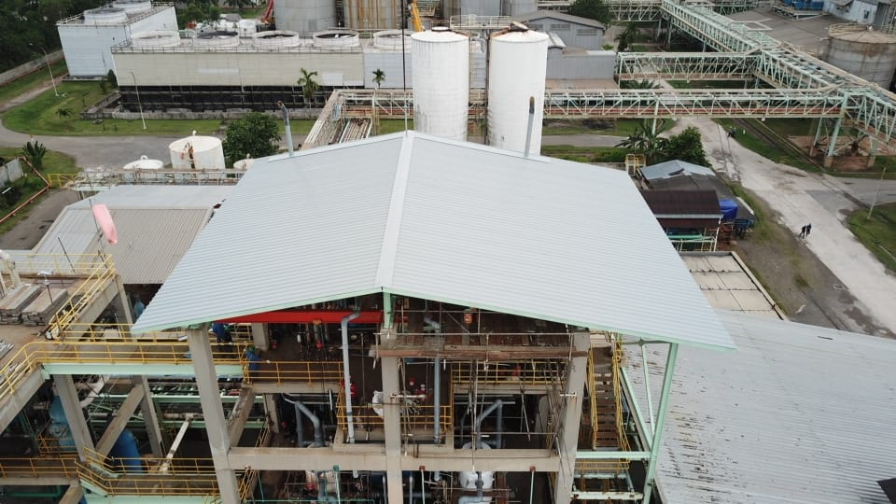REPLACE EXISTING DAMAGED ROOF SHEET AND PURLINS AT UPPER STRUCTURE OF CLORINE DIOXIDE
2. 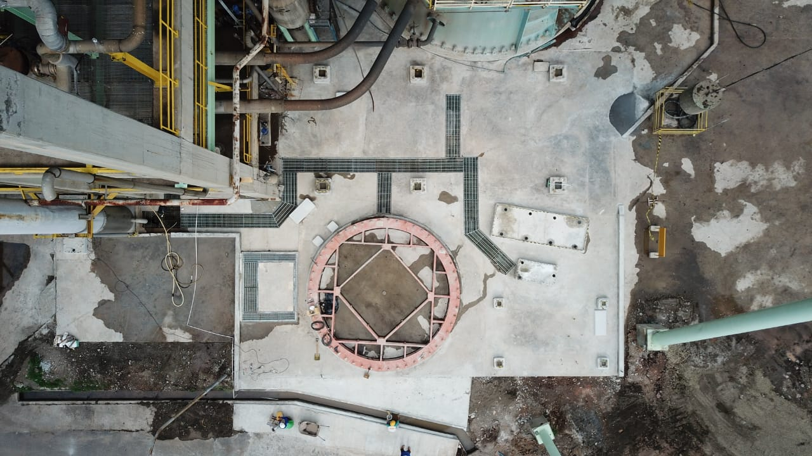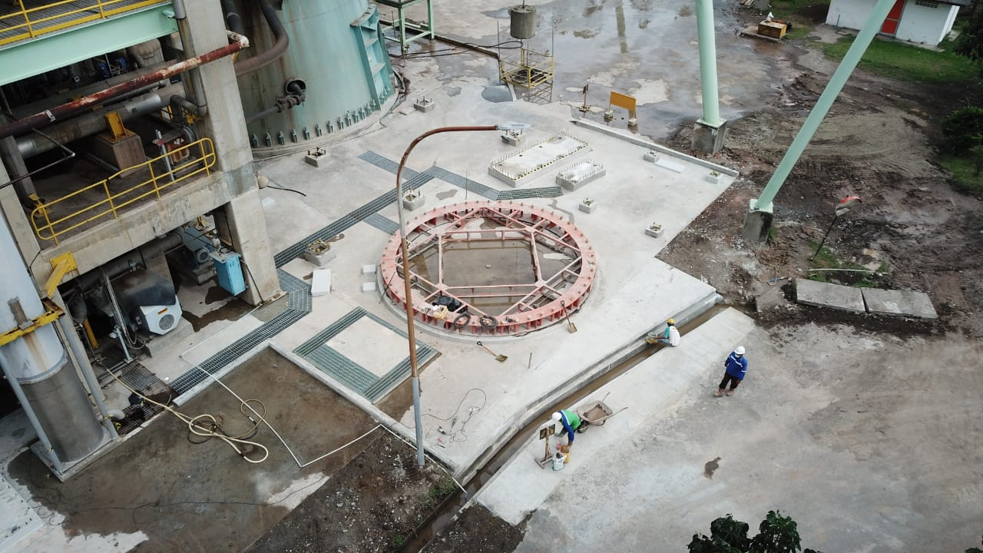CONSTRUCT NEW CONCRETE FOUNDATION AND OTHER SUB STRUCTURE OF G3 COOKING
3. 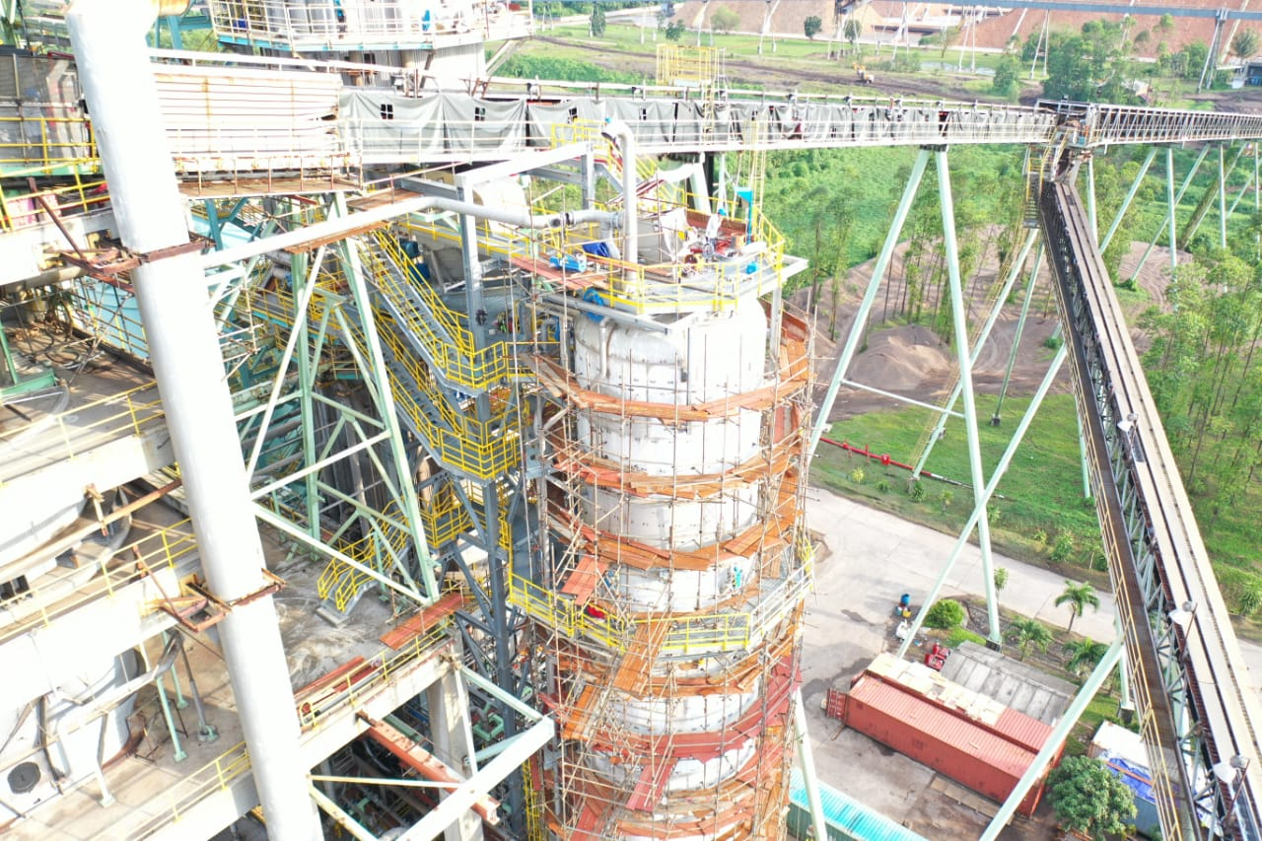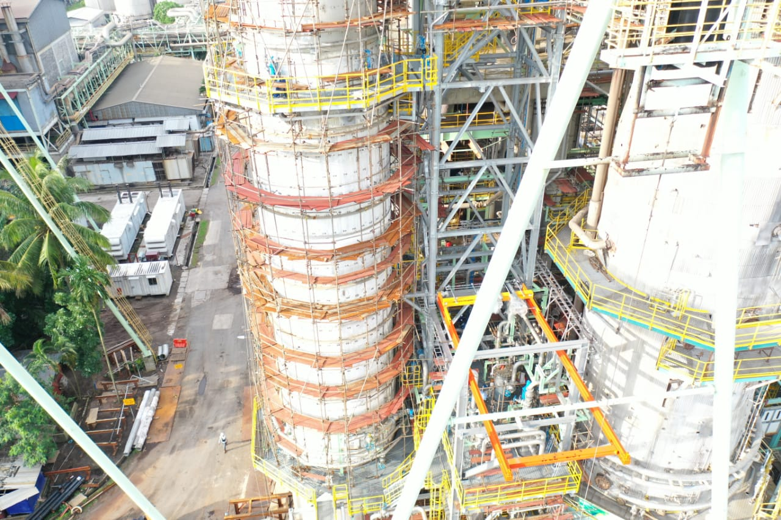FABRICATE AND INSTALL STEEL STRUCTURE G3 COOKING REBUILD
4. INSTALL WOODEN WALL WITH STEEL FRAME AT BARK STORAGE #1 & #2

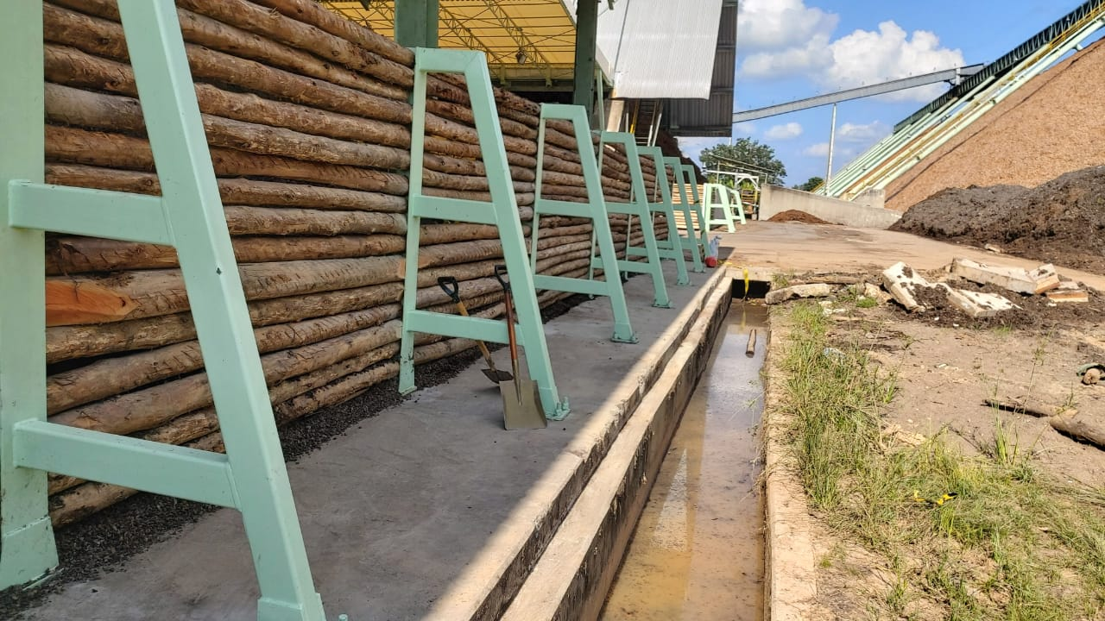

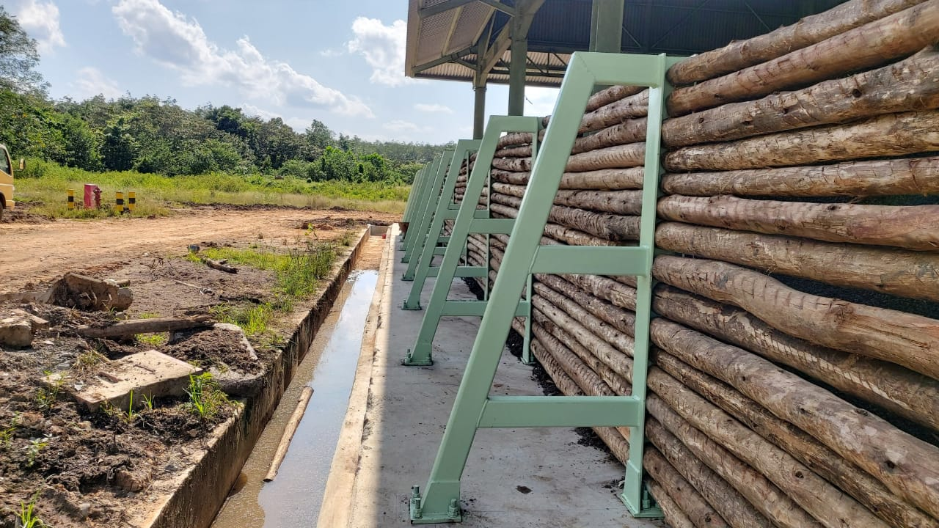

1. PARTIALLY REPAIR DAMAGED WOODEN ROOF AND ROOF SHEET OF SAFETY OFFICE

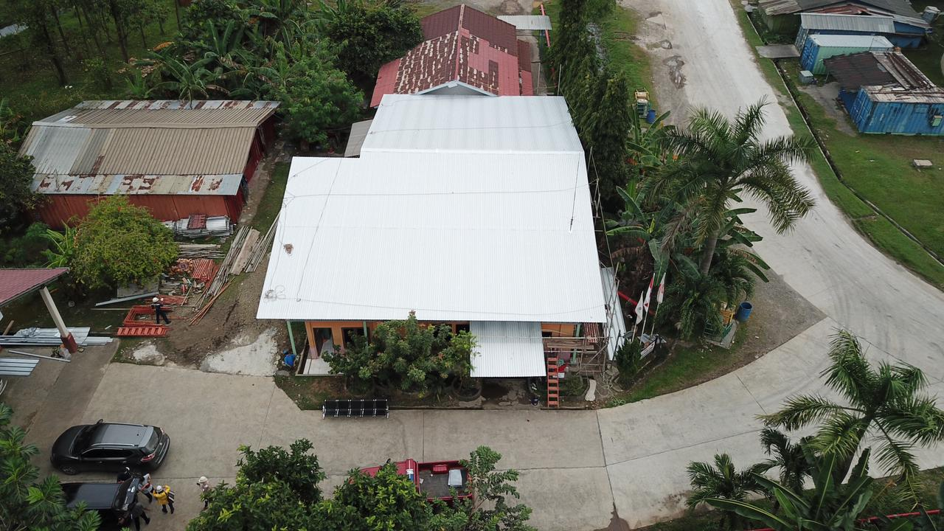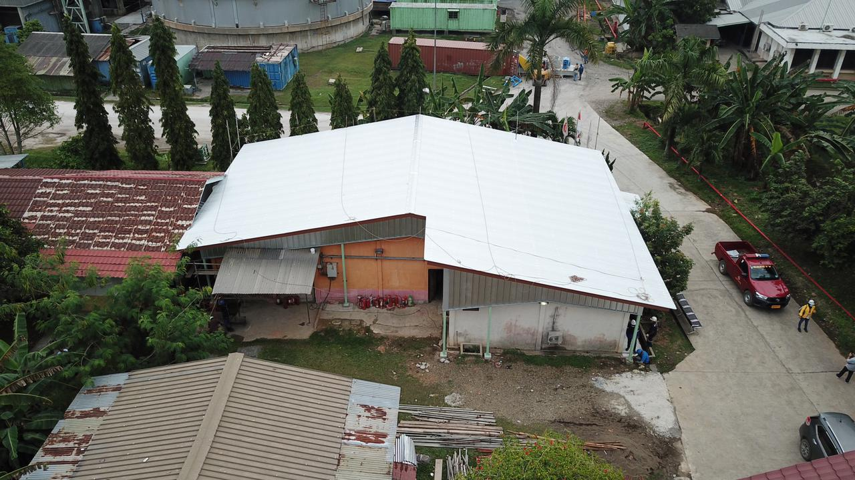

1. WOODYARD DRAINAGE

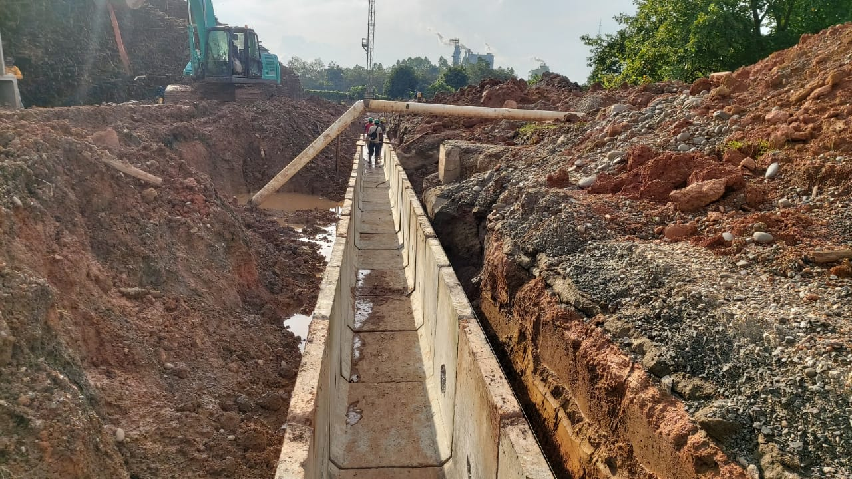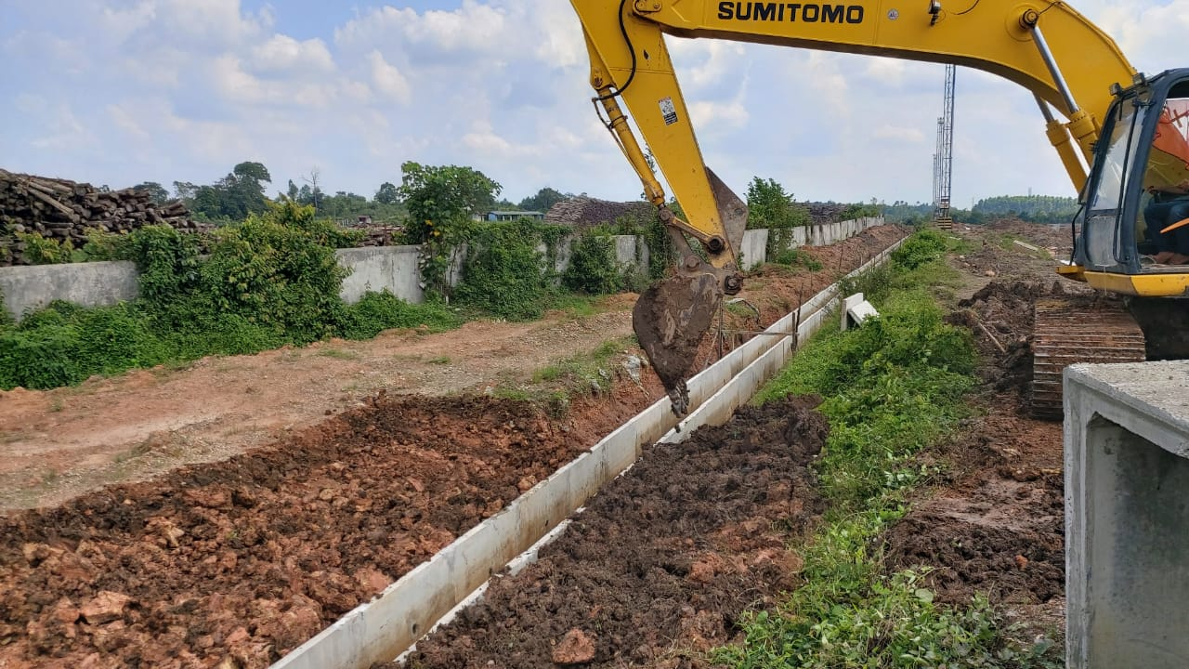

PT YOGMA WIJAYA KUSUMA – Tarahan Project

1. 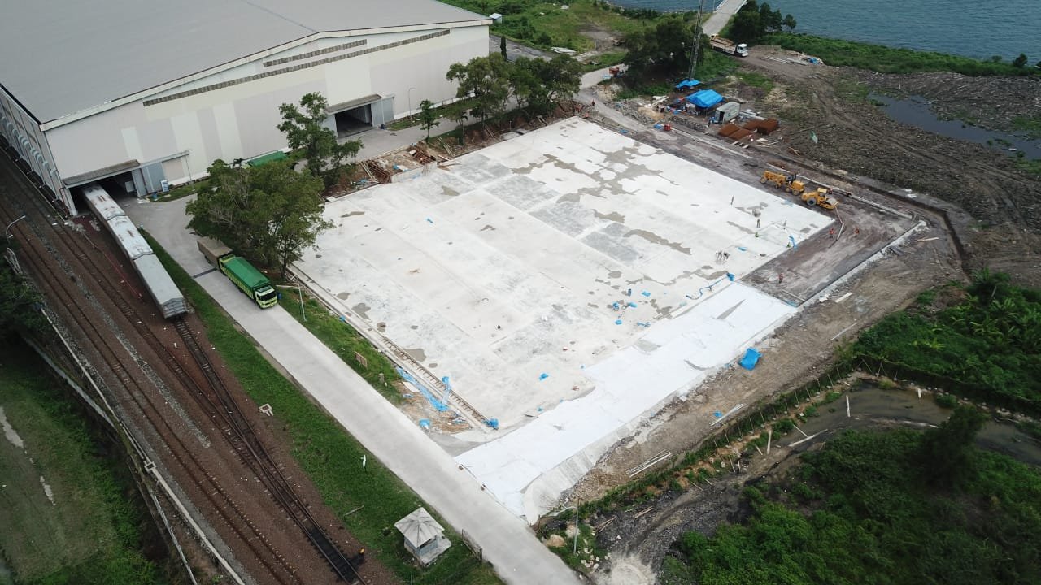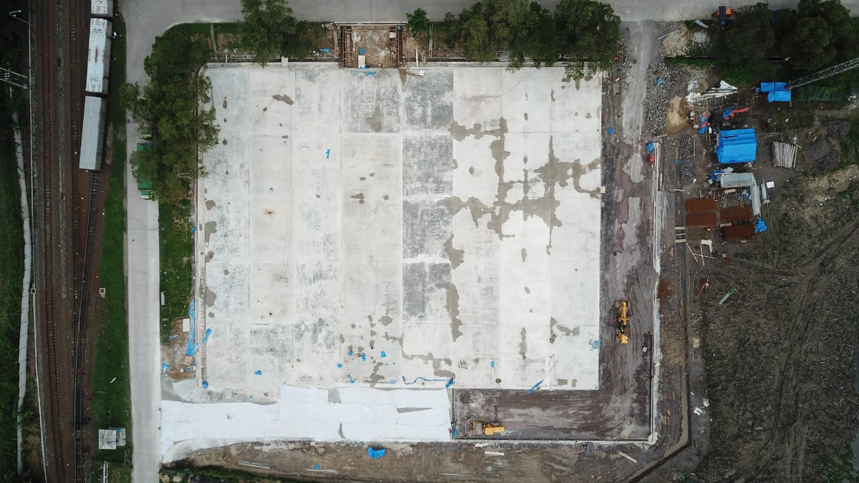Construct New Container Yard
2. 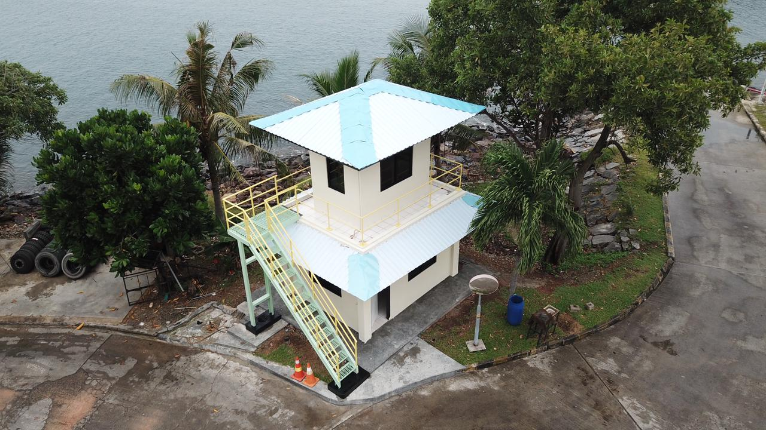 Repair Radio Room At Tarahan Site
3. 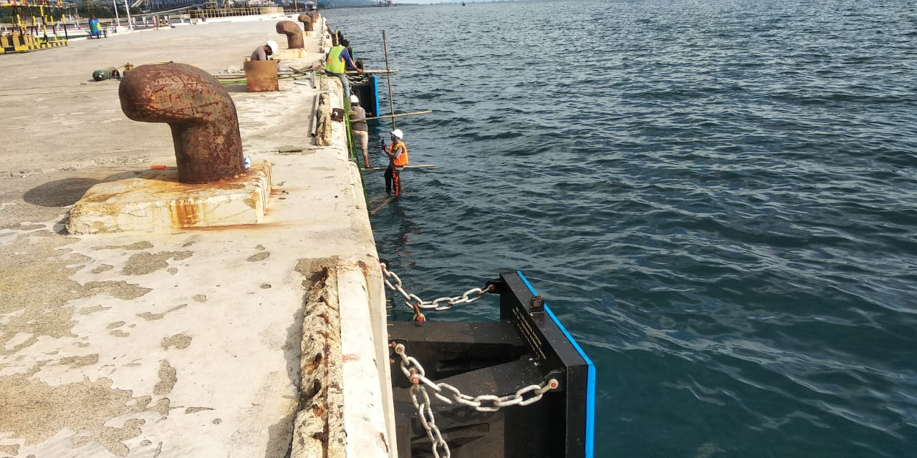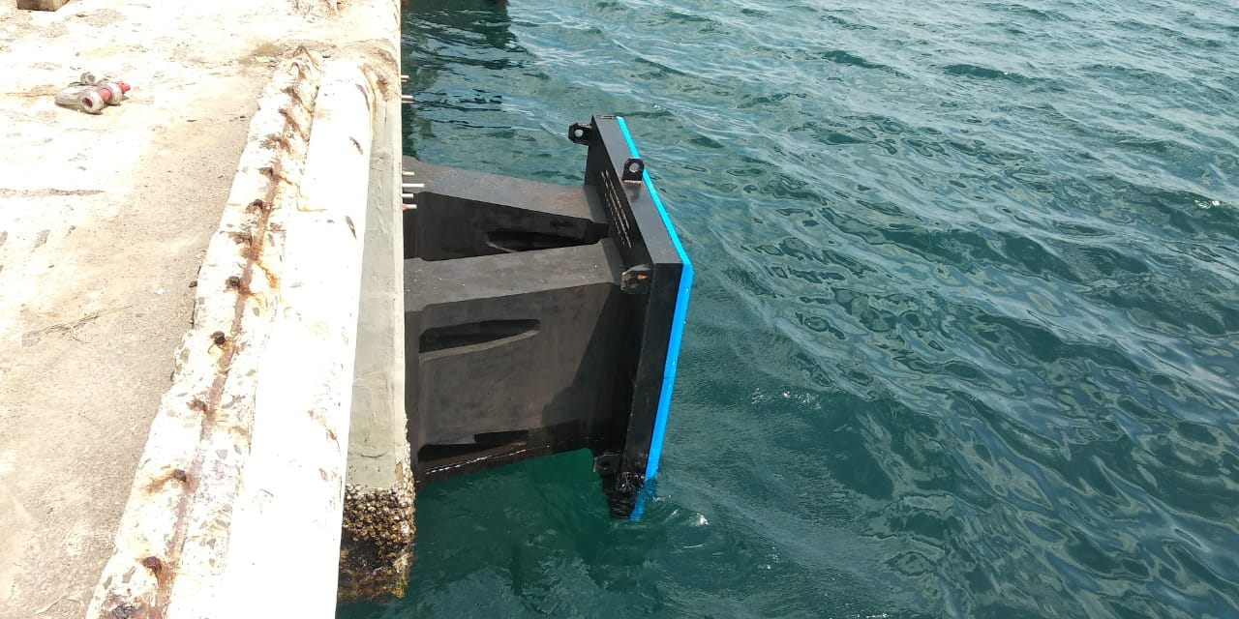 Fender Jetty
4. REPLACE AND RETIGHTENING EXISTING BOLT OF GIRDER CRANE

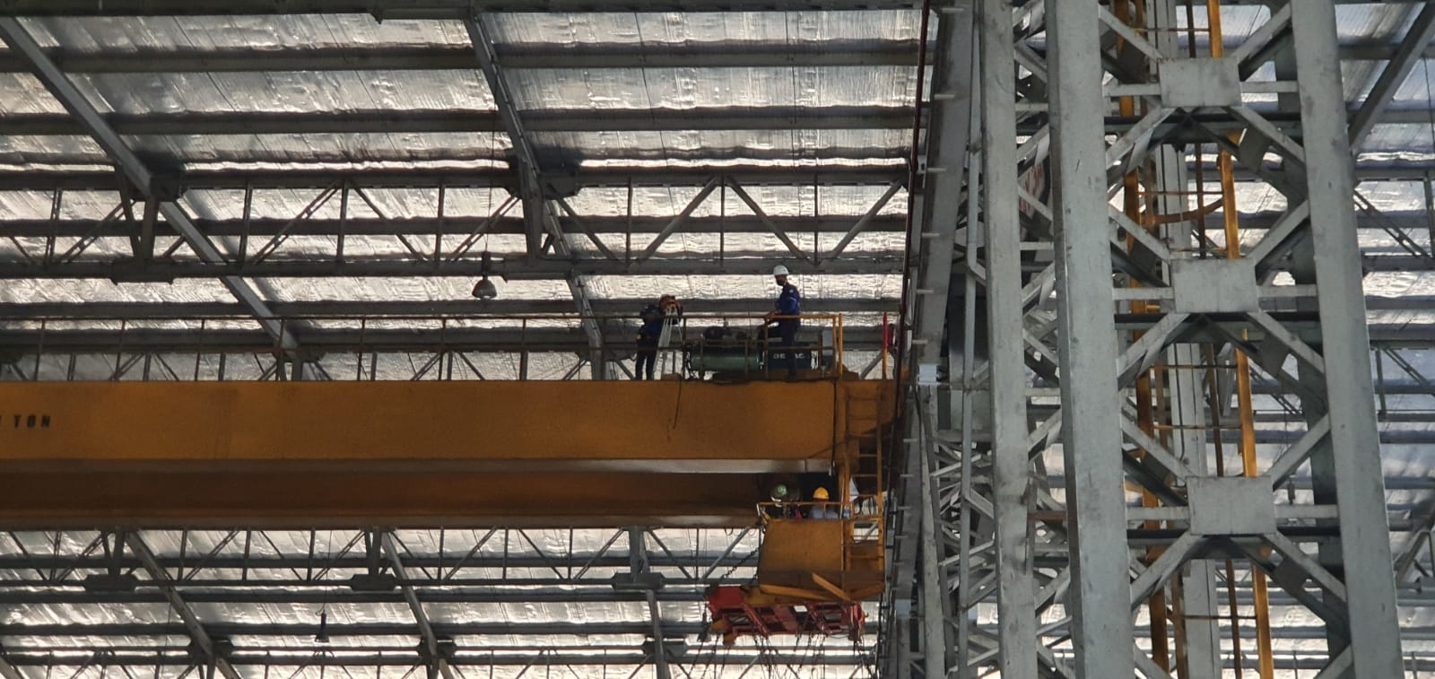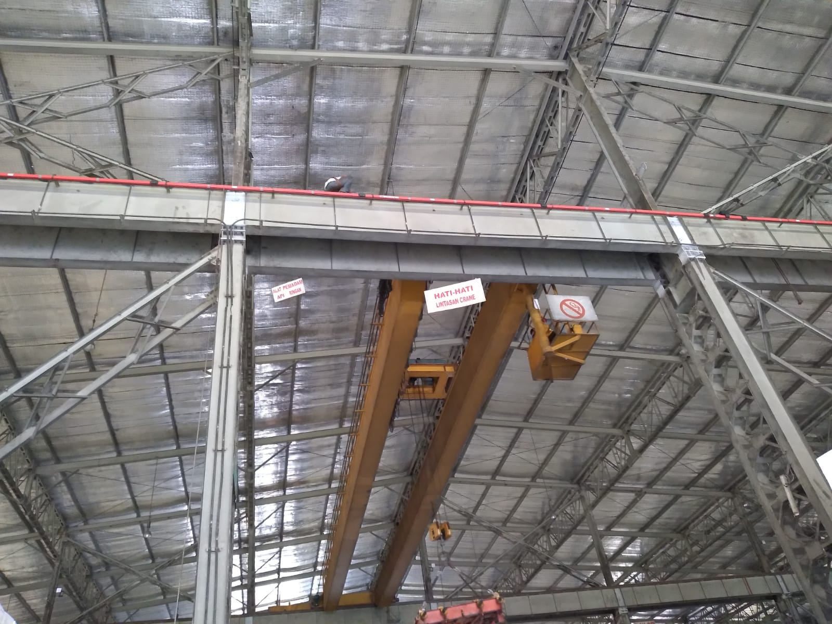

PT YOGMA WIJAYA KUSUMA -MILL SITE PROJECT

1. CONSTRUCT NEW BARK STORAGE #2

